**CE101 Engineering Drawing July- Nov 2019**

**Indian Institute of Technology Guwahati**

**Lab Sheet-1 Lettering, Dimensions and Scales Thursday Afternoon**

**Max Marks: 90 + 10 (overall neatness) Date: 08.08.2019**

1. Prepare your drawing sheet by using 20 mm left hand margin, and 10 mm for the top, bottom and right hand side margins. **[5]**

Complete the title block (65 mm x 160 mm, as shown) at the right bottom corner of your drawing sheet. The dimensions are for reference, and need not be marked for the title block. **[20]**

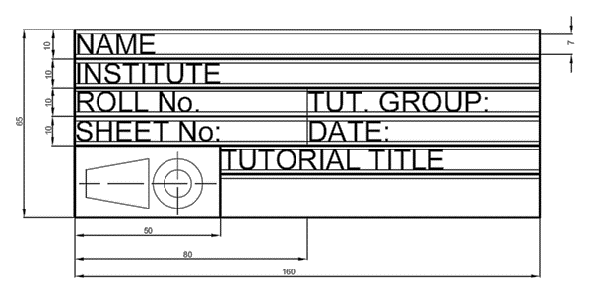

1. Write freehand the following sentence using single stroke vertical letters. The capital letters should be of height 7 mm. Follow the specifications of A-Type lettering for the other alphabets. **[15]**

**The Quick Brown Fox jumped   
over a Lazy Dog**

1. A rectangular garden of area 196 m2 is represented on a map by a rectangle of area 4 cm2. Construct a plain scale to read up to a single meter, and long enough to measure up to 9.8 decameters. Mark a distance of 2.2 dam on the scale. **[15]**
2. The following have several marked and unmarked mistakes in dimensioning. Reproduce the object and properly dimension the same. Follow the unidirectional system of dimensioning. **[20]**

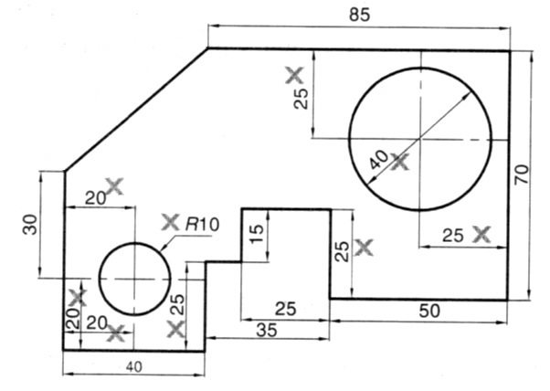

1. Construct a forward Vernier scale of RF = 1:50000 to show kilometers, hectometers and decameters. The scale should be capable of reading up to 4 km. Mark a distance of   
   1.19 km on the scale. **[15]**